**Fitflex-your fitness personal companion**

**Project Documentation**

**1. Introduction**

Project Title:

**Fitflex-your fitness personal companion**

**Team Members:**

**Team ID :** SWTID1741230126151843

Team Size : 4

Team Leader : P PREETHI(Email ID [preethiprakash797@gmail.com](mailto:preethiprakash797@gmail.com))

Team member :R POOJA(Email ID: [Poojaramesh968@gmail.com](mailto:Poojaramesh968@gmail.com))

Team member : PRIYADARSHINI V(Email ID: priyadharshini12293@gmail.com)

Team member : S RAJALAKSHMI(Email ID:srajalakshmi909@gmail.com)

**2. Project Overview**

Purpose:

The Fitness Tracker App is designed to help users monitor their fitness journey by tracking workouts, steps, calories burned, and progress over time. The app provides personalized recommendations based on user data.

Features:

* User authentication and profile management
* Workout tracking (predefined & custom workouts)
* Step counter and calorie tracker
* Integration with wearable devices
* Progress analytics and reports
* Community and social sharing

**3. Architecture**

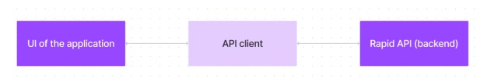

Component Structure:

The app is built using React.js with modular components for user authentication, dashboard, workout tracking, and analytics.

State Management:

The app uses Redux Toolkit for managing global state and Context API for lightweight state handling.

Routing:

React Router is used to manage navigation between different pages, such as Home, Dashboard, Workouts, and Profile.

**4. Setup Instructions**

Prerequisites:

Node.js (latest stable version)

npm

React.js

Firebase (for authentication and database)

**Installation:**

1. Clone the repository:

git clone: https://github.com/ArulselviRaja/FitnessApp-React-

2. Navigate to the project directory:

cd code

3. Install dependencies:

npm install

4. Configure environment variables (Firebase API keys, etc.).

5. Start the application:

npm start

**5. Folder Structure**

Client:

src/components: Reusable UI components (buttons, cards, modals)

src/pages: Individual screens (Home, Dashboard, Profile, etc.)

src/services: API calls and data fetching

src/context: Context API and state management

src/assets: Images, icons, and styles

Utilities:

Helper functions for formatting data, API integration, and authentication handling.

**6. Running the Application:**

Start the frontend server:

npm start

The app will be available at http://localhost:3000.

**7. Component Documentation**

Key Components:

Navbar: Navigation bar for switching between pages.

WorkoutCard: Displays workout details and tracking options.

Dashboard: Provides user analytics and daily progress.

Reusable Components:

Button: Customizable button component.

InputField: Styled input fields for user input.

Loader: Loading spinner for asynchronous operations.

**8. State Management**

Global State:

Managed using X Rapid API Toolkit for user authentication, workout tracking, and progress data.

Local State:

Component-level state managed using React’s useState() for UI interactions (modal visibility, form inputs, etc.).

**9. User Interface**

Screenshots/GIFs:

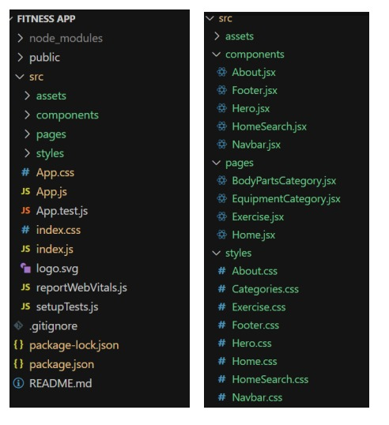

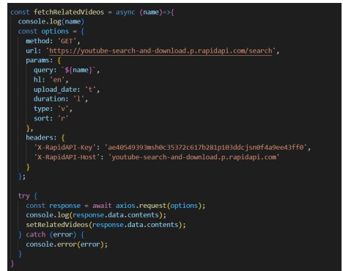

Include UI snapshots demonstrating login, workout tracking, analytics, etc.

**10. Styling**

CSS Frameworks/Libraries:

Tailwind CSS for utility-based styling.

Styled-Components for dynamic theming.

**11. Testing**

Testing Strategy:

Unit testing with Jest and React Testing Library.

End-to-end testing with Cypress.

Code Coverage:

Ensuring test coverage for all core functionalities using Jest

**12. Screenshots or Demo**

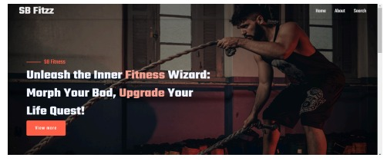

Live Demo:

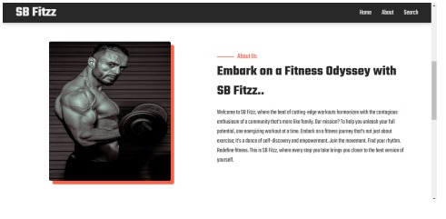

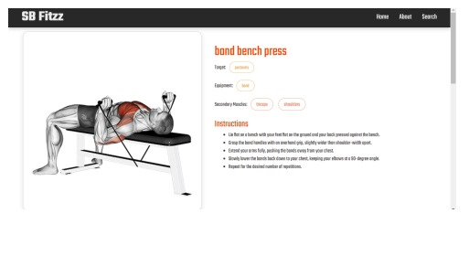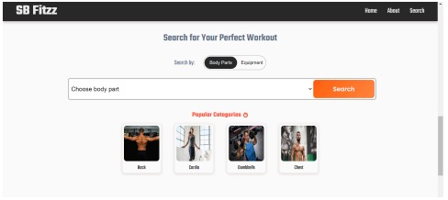

**13. Known Issues**

Bugs:

Occasionally, step tracking may show inconsistent results.

UI glitches on certain mobile devices.

**14. Future Enhancements**

New Features:

**💪💪Fitness Tracker Dashboard**\*\*  
A responsive fitness tracking dashboard built with React.js to monitor workout progress, steps, calories burned, and more.

**Features**  
🔍 **Track workouts and fitness progress** – Log both predefined and custom workouts.

📊 **Real-time workout tracking updates** – Get live updates of your daily activity (steps, calories, workout progress).  
💪 **User-specific analytics** – View stats like total calories burned, steps taken, and progress over time.  
🌐 **Interactive and user-friendly interface** – Intuitive and easy navigation across the app.  
📱 **Fully responsive design** – The app is optimized for mobile and desktop use.

AI-based workout recommendations.

Integration with Google Fit & Apple Health.

Social challenges and leaderboards.

Milestone 1:

Project setup and configuration.

● Installation of required tools: To build the FitFlex app, we'll need a developer's toolkit. We'll leverage React.js for the interactive interface, React Router Dom for seamless navigation, and Axios to fetch fitness data. To style the app, we'll choose either Bootstrap or Tailwind CSS for pre-built components and a sleek look. Open the project folder to install necessary tools. In this project,

● For further reference, use the following resources o https://react.dev/learn/installation o https://react-bootstrap-v4.netlify.app/getting-started/introduction/ o https://axios-http.com/docs/intro https://reactrouter.com/en/main/start/tutorial Milestone 2: Project Development

❖ Setup the Routing paths Setup the clear routing paths to access various files in the application.

❖ Develop the Navbar and Hero components

❖ Code the popular search/categories components and fetch the categories from rapid Api.

❖ Additionally, we can add the component to subscribe for the newsletter and the footer.

❖ Now, develop the category page to display various exercises under the category.

❖ Finally, code the exercise page, where the instructions, other details along with related videos from the YouTube will be displayed.

**“Fitness is more than just a physical transformation—it's a journey of self-discovery, growth, and resilience. Every step, every rep, and every drop of sweat brings you closer to your best self. Remember, it’s not about being perfect, it’s about making progress. Whether you're tracking your steps, conquering a new workout, or reaching a fitness goal, each moment is an opportunity to push past your limits and redefine what's possible. Stay focused, stay motivated, and believe in your strength. The only limit that exists is the one you place on yourself, so break through it and become the best version of YOU."**